**DESIGN DB MODEL FOR GUVI ZEN CLASS**

**- - users:**

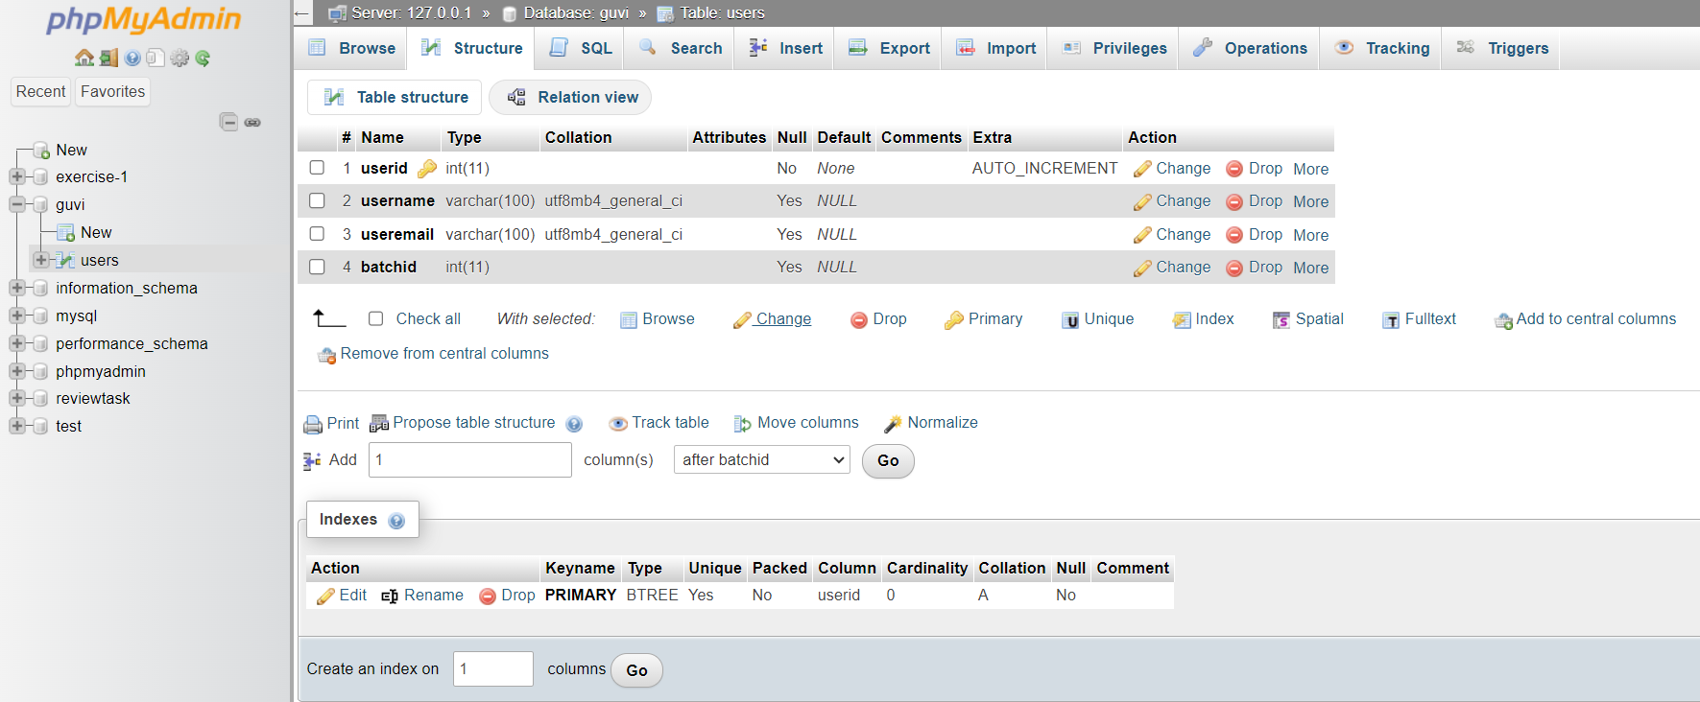

CREATE TABLE users (

userid INT AUTO_INCREMENT PRIMARY KEY,

username VARCHAR(100),

useremail VARCHAR(100),

batchid INT

);

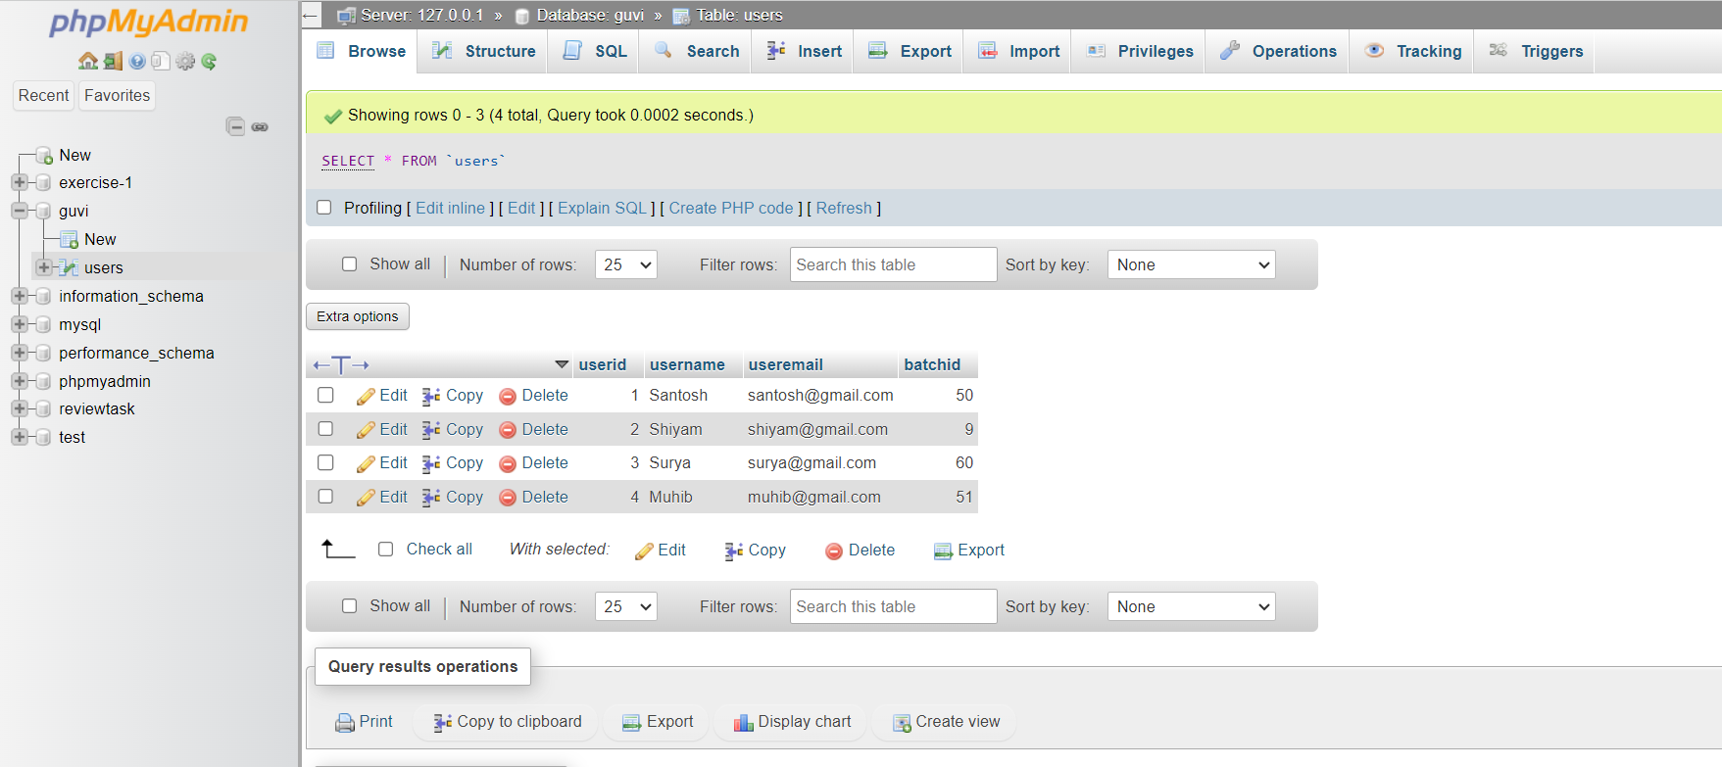

INSERT INTO `users`(`username`, `useremail`, `batchid`) VALUES

('Santosh','santosh@gmail.com',50),

('Shiyam','shiyam@gmail.com',09),

('Surya','surya@gmail.com',60),

('Muhib','muhib@gmail.com',51);

**- - CodeKata:**

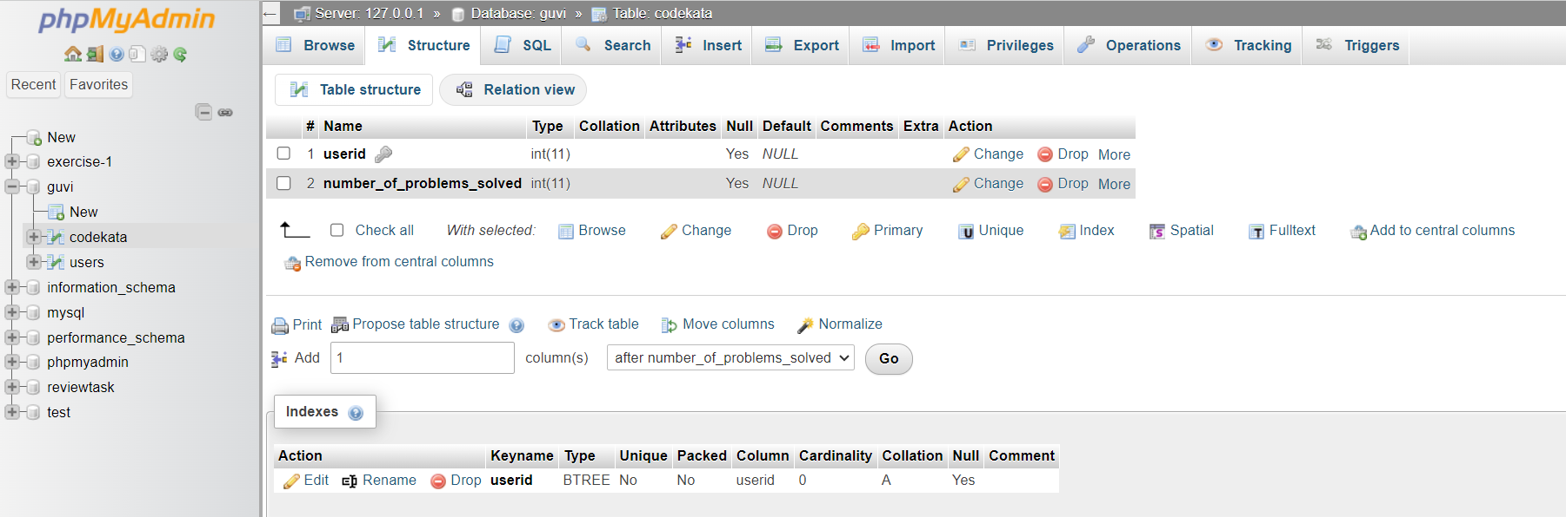

CREATE TABLE codekata(

userid INTEGER,

number_of_problems_solved INTEGER,

FOREIGN KEY (userid) REFERENCES users(userid)

);

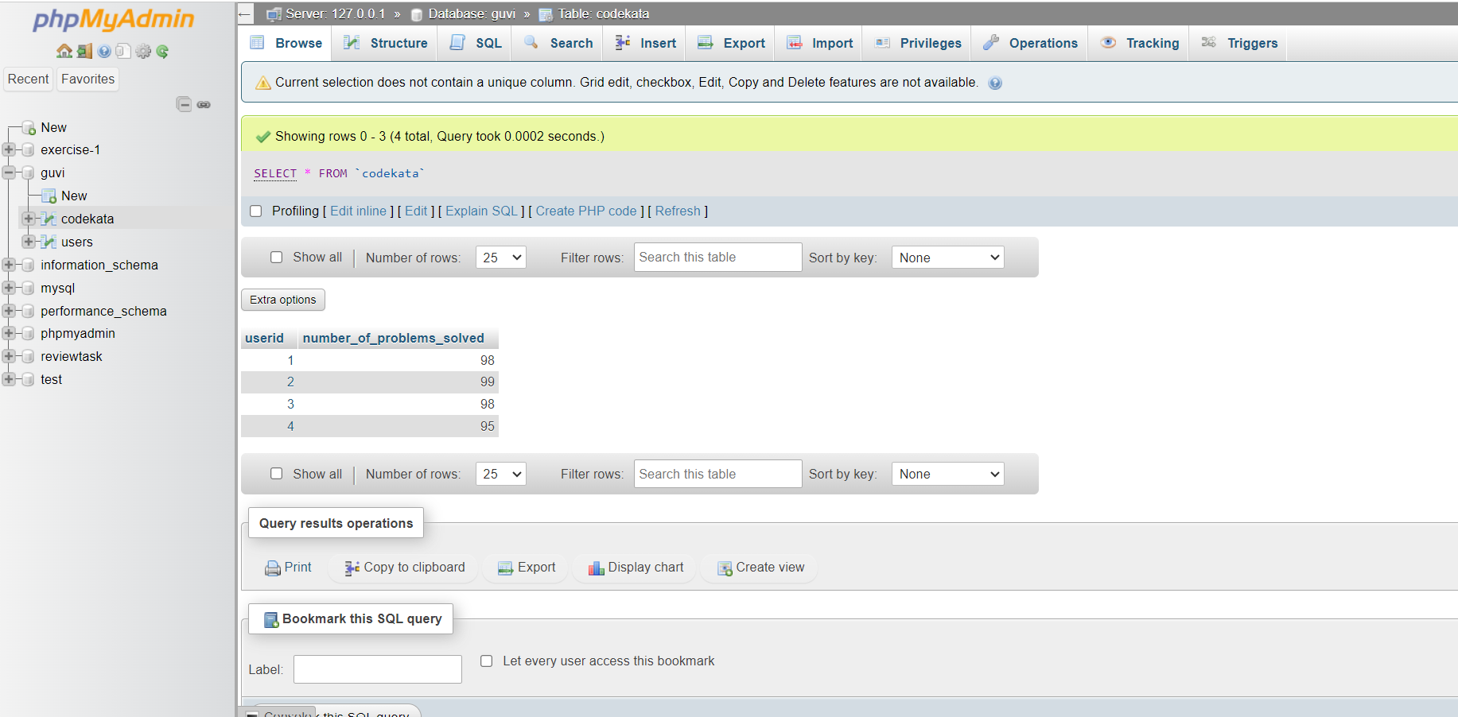

INSERT INTO `codekata`(`userid`, `number_of_problems_solved`) VALUES

('1','98'),

('2','99'),

('3','98'),

('4','95');

**- - Company Drives:**

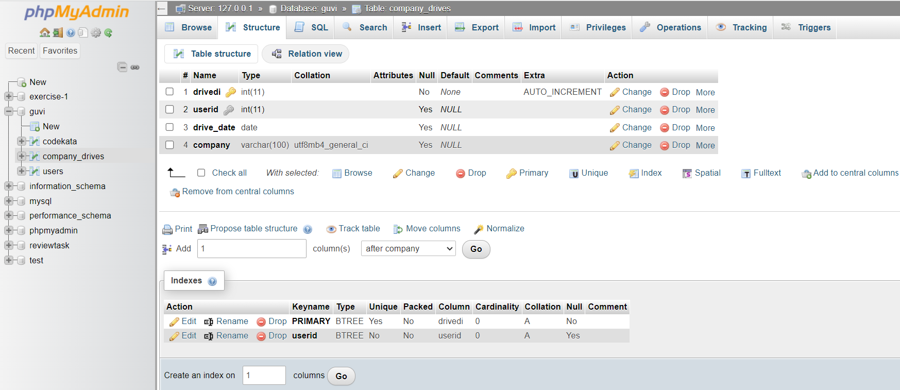

CREATE TABLE company_drives (

drivedi INTEGER AUTO_INCREMENT PRIMARY KEY,

userid INTEGER,

drive_date DATE,

company VARCHAR(100),

FOREIGN KEY (userid) REFERENCES users(userid)

);

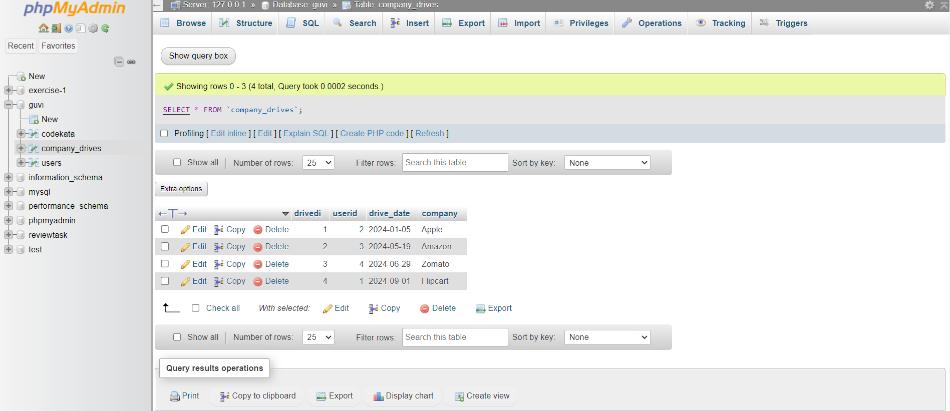

INSERT INTO `company_drives`(`userid`, `drive_date`, `company`) VALUES

(2,'2024-01-05','Apple'),

(3,'2024-05-19','Amazon'),

(4,'2024-06-29','Zomato'),

(1,'2024-09-01','Flipcart');

**- - Mentors:**

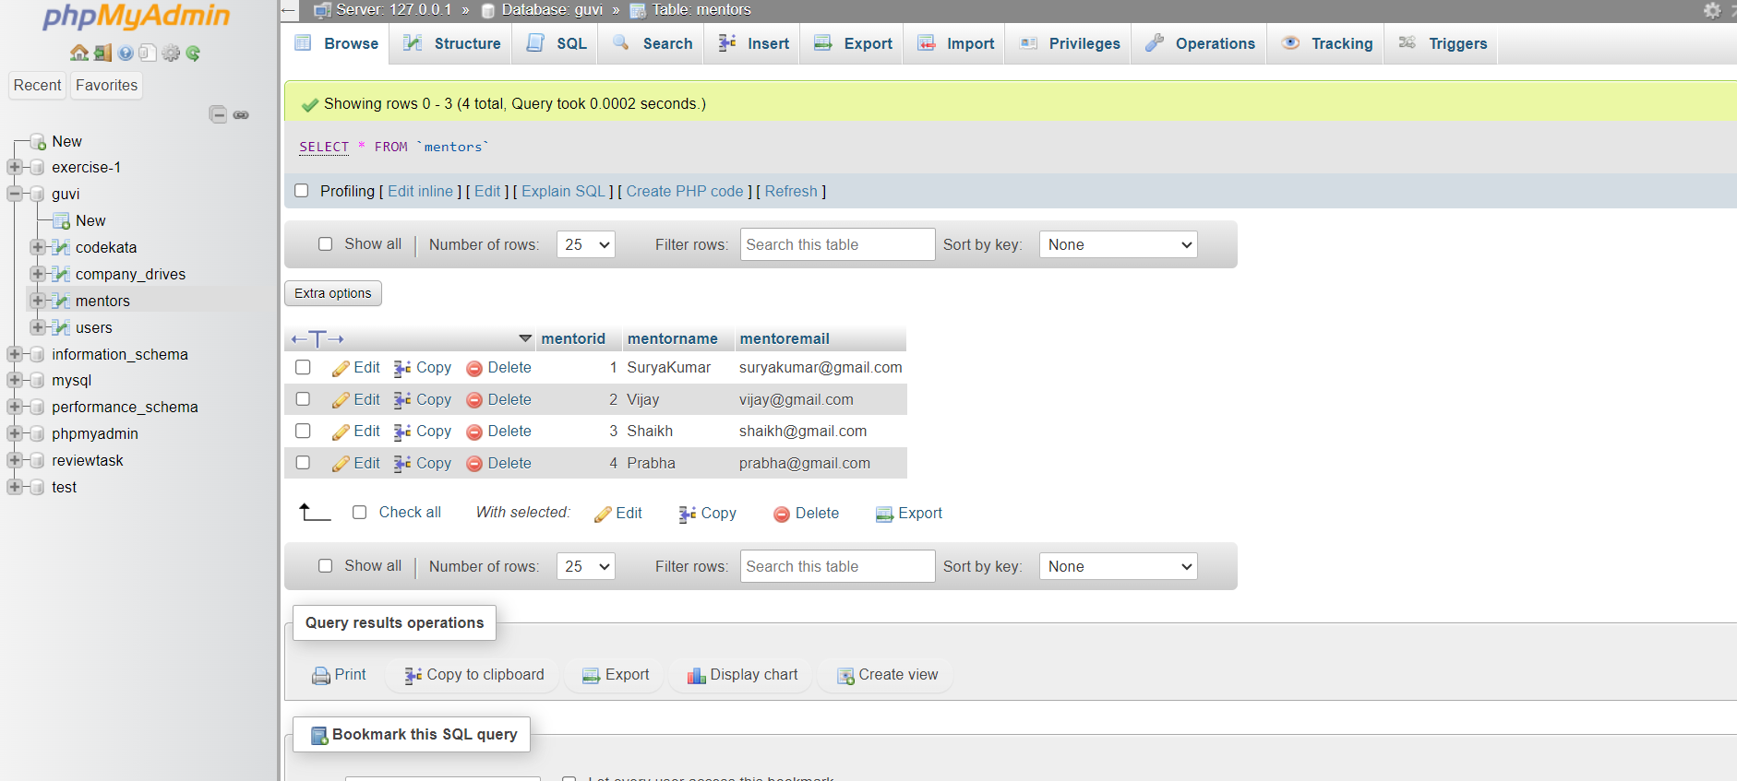

CREATE TABLE mentors(

mentorid INTEGER AUTO_INCREMENT PRIMARY KEY,

mentorname VARCHAR(100),

mentoremail VARCHAR(100)

);

INSERT INTO `mentors`(`mentorname`, `mentoremail`) VALUES

('SuryaKumar','suryakumar@gmail.com'),

('Vijay','vijay@gmail.com'),

('Shaikh','shaikh@gmail.com'),

('Prabha','[prabha@gmail.com](mailto:prabha@gmail.com)');

**- - Topics:**

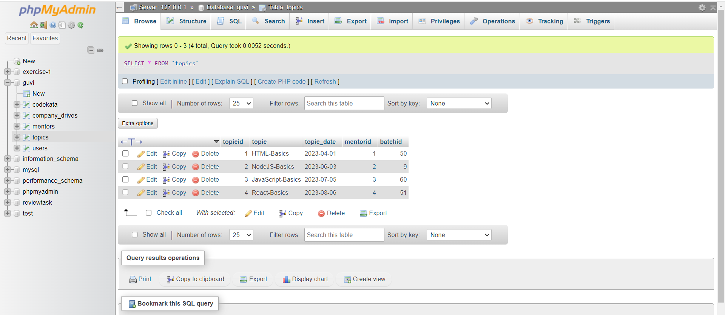

CREATE TABLE topics (

topicid INTEGER AUTO_INCREMENT PRIMARY KEY,

topic VARCHAR(200),

topic_date Date,

mentorid INTEGER,

batchid INTEGER,

FOREIGN KEY (mentorid) REFERENCES mentors(mentorid)

);

INSERT INTO `topics`(`topic`, `topic_date`, `mentorid`, `batchid`) VALUES

('HTML-Basics','2023-04-01','1','50'),

('NodeJS-Basics','2023-06-03','2','09'),

('JavaScript-Basics','2023-07-05','3','60'),

('React-Basics','2023-08-06','4','51');

**- - Tasks:**

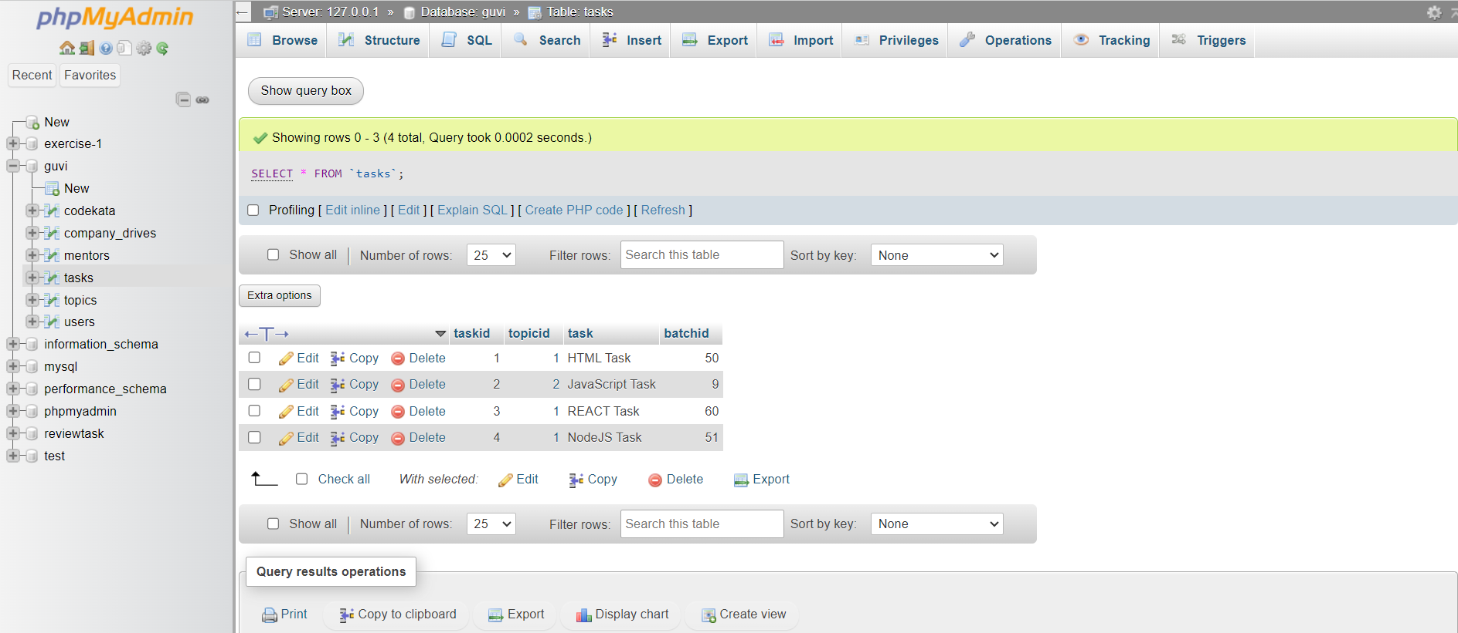

CREATE TABLE tasks (

taskid INTEGER AUTO_INCREMENT PRIMARY KEY,

topicid INTEGER,

task VARCHAR(100),

batchid INTEGER,

FOREIGN KEY (topicid) REFERENCES topics(topicid)

);

INSERT INTO `tasks `(`topicid`, `task`, `batchid`) VALUES

(1, 'HTML task', '50'),

(2, 'NodeJS task', '09'),

(3, 'JavaScript task', '60'),

(4, 'React task', '51');

**- - Attendance:**

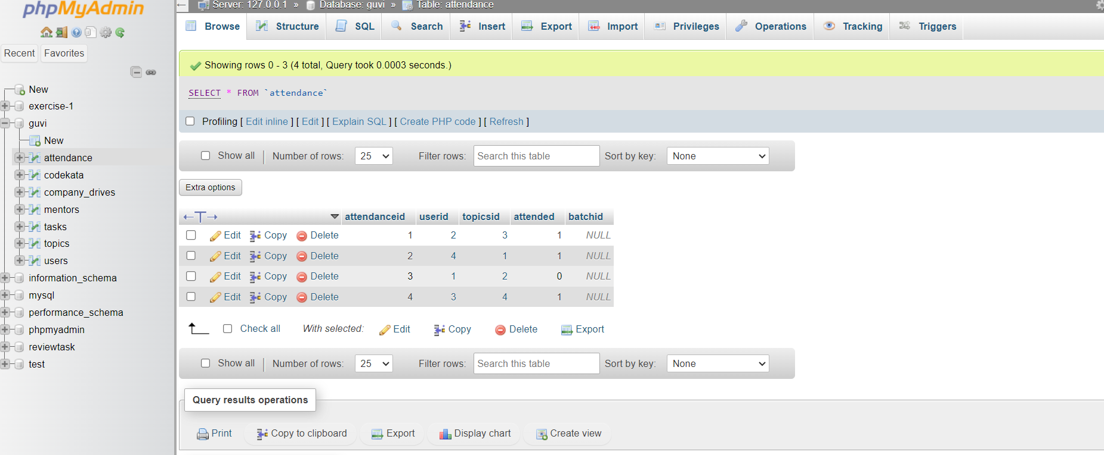

CREATE TABLE attendance (

attendanceid INTEGER AUTO_INCREMENT PRIMARY KEY,

userid INTEGER,

topicsid INTEGER,

attended BOOLEAN,

batchid INTEGER,

FOREIGN KEY (userid) REFERENCES users(userid),

FOREIGN KEY (topicsid) REFERENCES topics(topicid)

);

INSERT INTO `attendance`(`userid`, `topicsid`, `attended`) VALUES

(2, 3, true),

(4, 1, true),

(1, 2, false),

(3, 4, true);

**ER DIAGRAM**

